  - My Details:
Name: Molly Parle
Student number: 20116875
Course: Computer Forensics and Security
Group: W1

  - Brief Overview:
- Home Page
- About Me
- My Interests & Skills
- Education
- Travel

  - Wireframes (balsamiq):
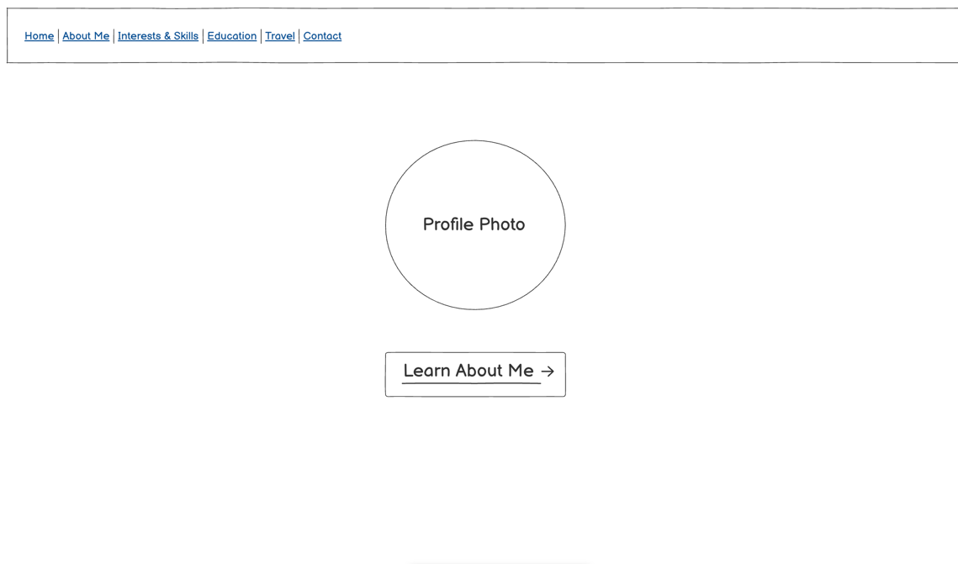

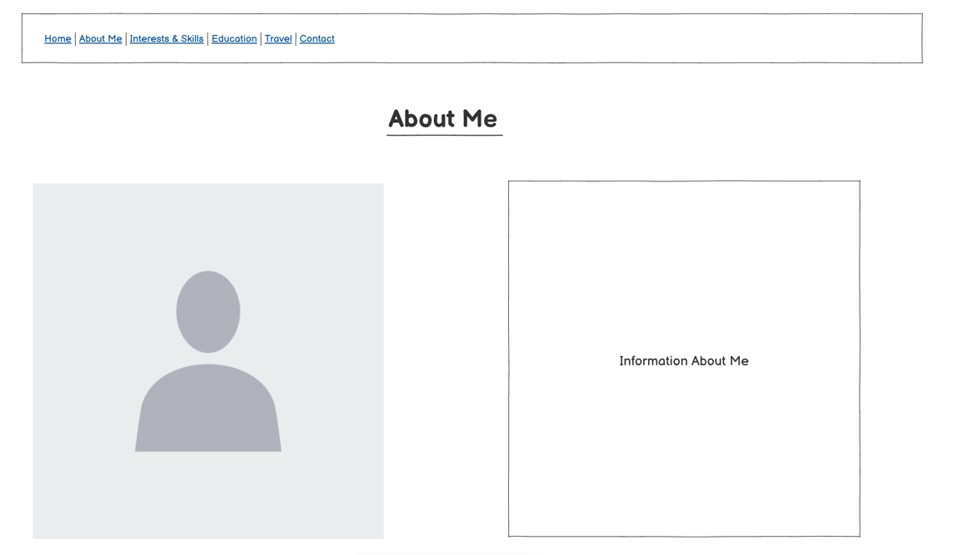

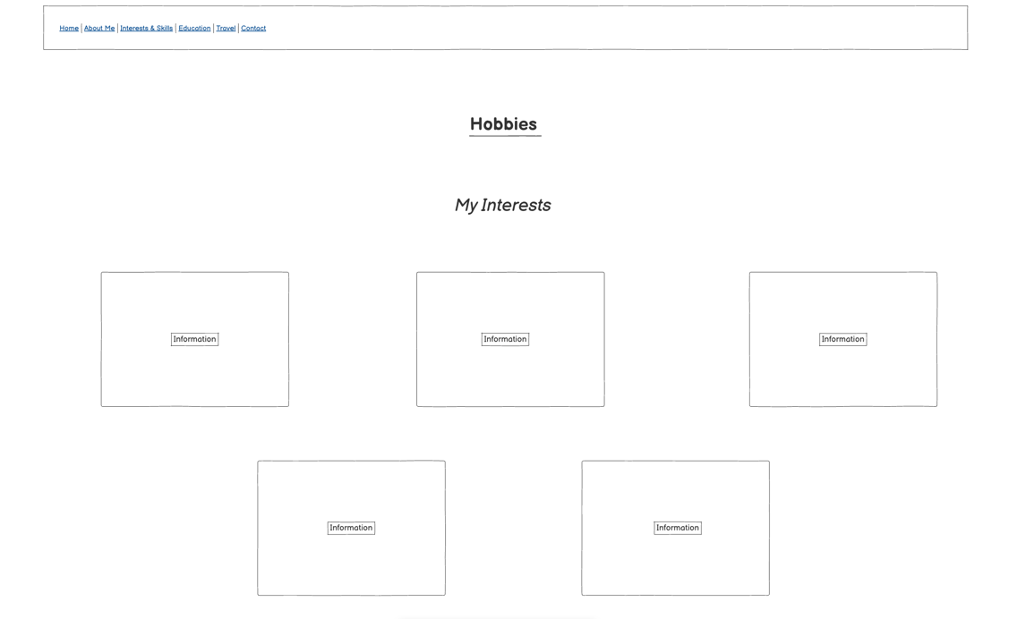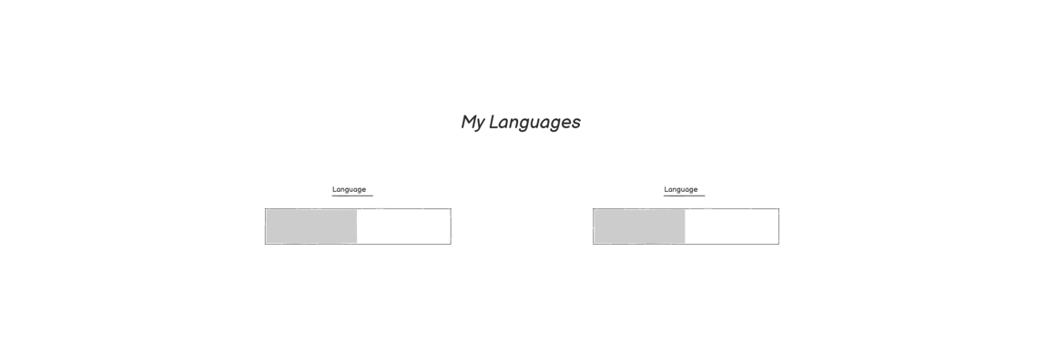

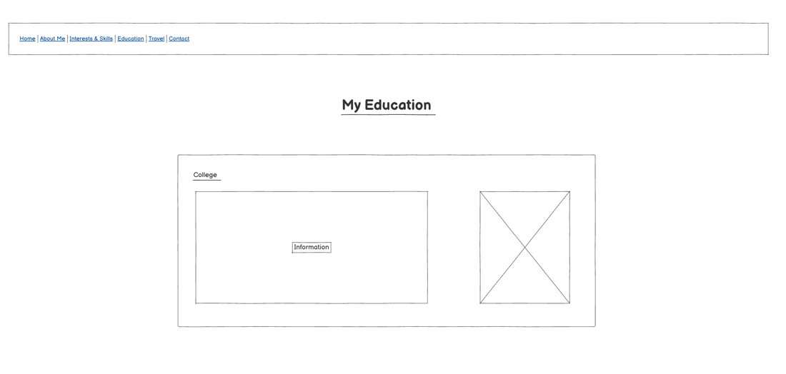
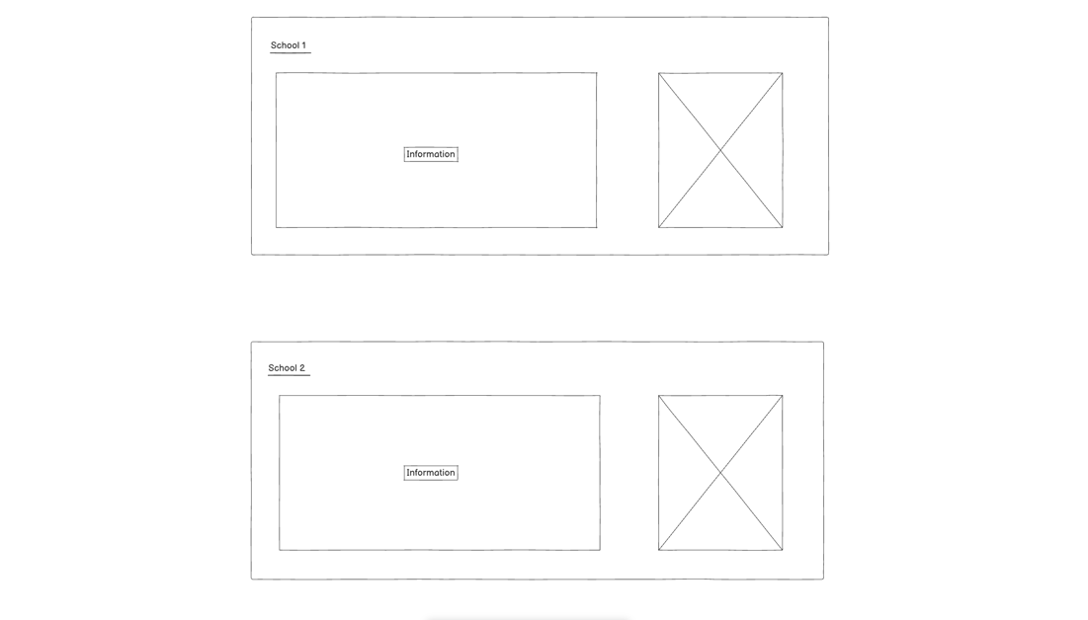
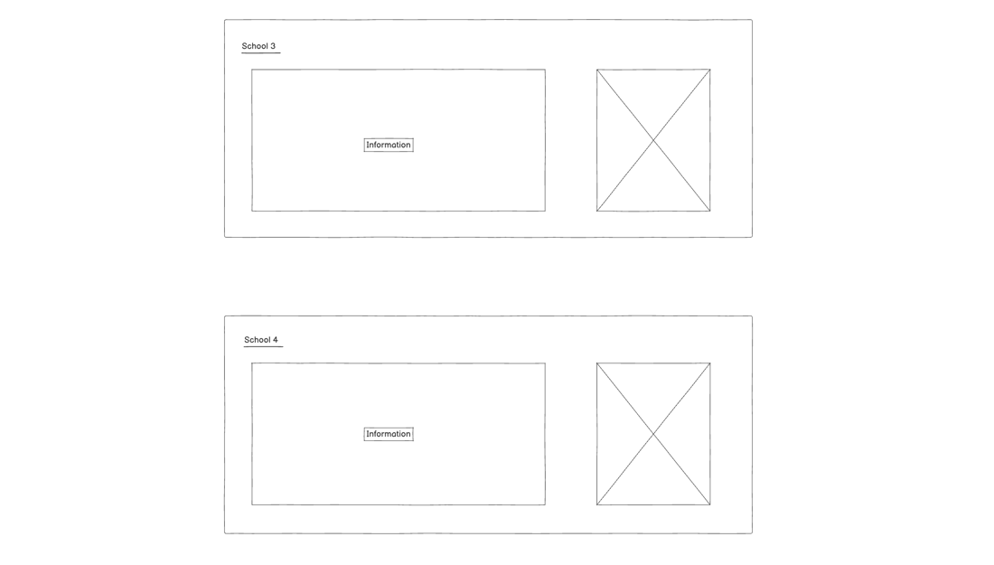

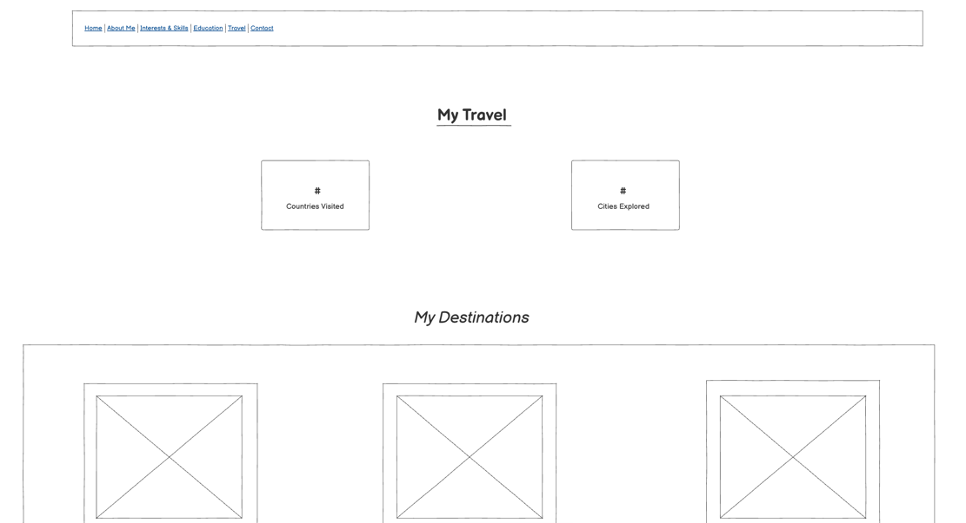
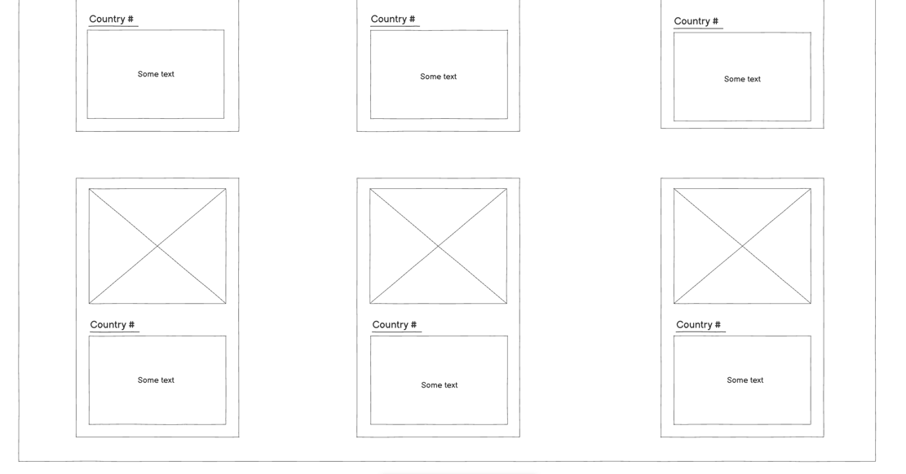

  - Visual Design:
- Background colour: black
- Main font colour: light pink
- Accent/border colour: bright pink
- Font: ‘Courier New’, Courier, monospace
- Headings: underlined
- Header: nav box
- Footer: copyright, year, name

